A Project Report on

***CAFÉ MANAGEMENT SYSTEM***

Submitted

in

Partial fulfillment

Of

AISSCE 2017-18

[As a part of the Informatics Practices Course (065)]

**SUBMITTED BY**

**SAKSHAM TANEJA**

**[Roll N0. 1640543 ]**

Under the Guidance of:

**SMT. KALPANA GUPTA**

PGT (Head, Dept. of IT)

**CONTENTS**

**ACKNOWLEDGEMENT**

**ACKNOWLEDGMENT**

**This project report based on the topic “Cafe management System" is a part of AISSCE 2018 for Informatics Practices (065) Practical Examination.**

**I worked on this project report with full dedication and enthusiasm. There are many people whom I want to thank who helped us for the development of this report.**

**First and foremost I would like to thank our school management for giving us such a well-equipped and modern lab to learn all the basic and advanced features of Net Beans IDE and MySQL.**

**I would also like to thank my parents and friends who helped me and the Almighty God who gave me strength and inspiration in achieving this task.**

**CERTIFICATE**

**This is to certify that this project report is prepared bearing RollNo.- for the accomplishment of Informatics Practices (065) Final Practical Exam of AISSCE 2018. This Project Report is prepared under the guidance and supervision of our computer faculty during the session 2017-18. In this project report NetBeans IDE is used as a Front End and MySQL is used as Back End.**

**signature**

**Name: Mrs. Kalpana Gupta Head, Dept. of IT**

**External**

**Signature**

**System requrement**

***The Hardware used:***

While developing the system, the used hardware are:

PC with Pentium Dual Core processor having 2.00 GB RAM,

Kingston 8 gb pen drive

***The Software used:***

* Microsoft Windows 7 as Operating System.
* Java NetBeans 7.2 as Front-end Development environment.
* MySQL as Back-end Sever with Database.
* MS-Word 2007 for documentation.

**MySQL TABLES**

**MySQL BACK ENCODING**

**Data Dictionary**

**CREATE DATABASE CAFE;**

**USE CAFE;**

**TABLES**

**1.PRODUCT**

**CREATE TABLE PRODUCT(product_idint primary**

**key,product_namevarchar(15),product_typevarchar(15),price int);**

**2.emp**

**create table emp (emp_id int primary key,name varchar(30),address varchar(40),cn_no varchar(10),designation varchar(20),salary float(7,2));**

**3.CUSTOMER**

**CREATE TABLE CUSTOMER(customer_idint primary key, name varchar(25), gender varchar(10), email_idvarchar(25), address varchar(25), contact_nobigint);**

**4.BOOKING**

**CREATE TABLE BOOKING(booking_idint primary key, customer_idint ,name varchar(20),no int, phone_nobigint, time varchar(5),FOREIGN KEY(customer_id) REFERENCES CUSTOMER(customer_id));**

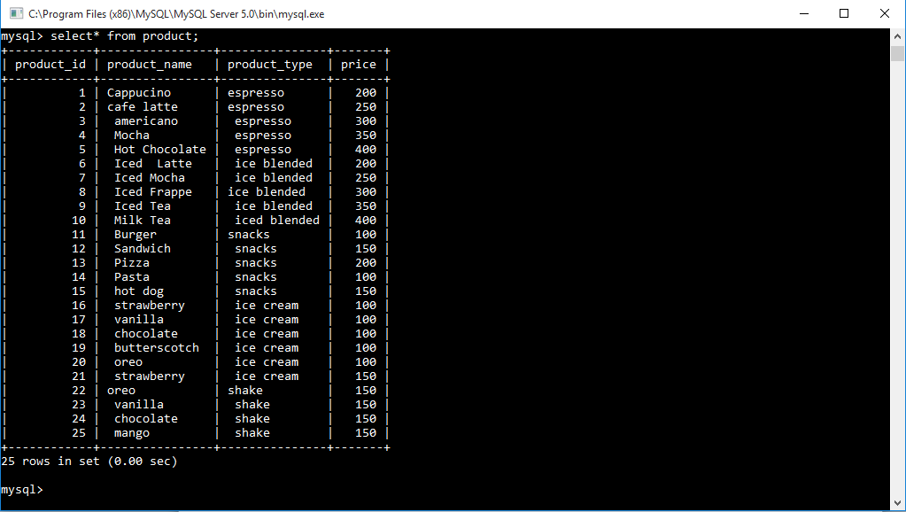

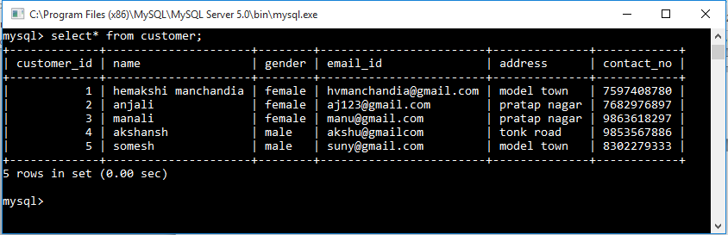

**ABOUT FRAMES**

|  |  |  |
| --- | --- | --- |
| SNO | FRAME NAME | Purpose |
| **1** | **NEWJFRAME** | OPENING FRAME |
| **2** | **NEWJFRAME1** | LOGIN FRAME |
| **3** | **NEWJFRAME2** | MANE MENU |
| **4** | **NEWJFRAME3** | INSERT PRODUCT |
| **5** | **NEWJFRAME4** | UPDATE PRODUCT |
| **6** | **NEWJFRAME5** | DELETE PRODUCT |
| **7** | **NEWJFRAME6** | SEARCH PRODUCT |
| **8** | **NEWJFRAME7** | NEW MEMBERSHIP |
| **9** | **NEWJFRAME8** | UPDATE MEMBER RECORD |
| **10** | **NEWJFRAME9** | DELETE MEMBER RECORD |
| **11** | **NEWJFRAME10** | SEARCH MEMBER |
| **12** | **NEWJFRAME11** | ORDER |
| **13** | **NEWJFRAME12** | BOOK A TABLE |
| **14** | **NEWJFRAME13** | UPDATE A BOOKING |
| **15** | **NEWJFRAME14** | DELETE A BOOKING |
| **16** | **NEWJFRAME15** | SHOW BOOKING |
| **17** | **NEWJFRAME16** | ADD EMPLOYEE |
| **18** | **NEWJFRAME17** | UPDATE EMPLOYEE |
| **19** | **NEWJFRAME18** | DELETE EMPLOYEE |
| **20** | **NEWJFRAME19** | SEARCH EMPLOYEE |
| **21** | **NEWJFRAME20** | EMPLOYEE ANYALYSIS |
| **22** | **NEWJFRAME21** | DETAILS OF PRODUCT |
| **23** | **NEWJFRAME22** | DETAILS OFEMPLOYEE |
| **24** | **NEWJFRAME23** | DETAILS OF BOOKING |

**INTRODUCTION**

**This is a web based portal for café records management. It has three tables namely products ,customers and bookings. It is a computerized database system which provides a framework and helps to execute the cafe management system, a critical process having many operations such as-**

**Keep the records of products.**

* **Manage the records of products.**
* **Keep the records of Customers.**
* **Manage the records of Customers.**
* **Keep the Table Bookings.**
* **Mange the Table Bookings.**

**It results in regular and timely bookings of table and delivery of products. The bookings can be easily managed by the user . Orders can be easily placed by it.**

CAFÉ MANAGEMENT SYSTEM

**User manual and source code**

**NEWJFRAME**



**CODING-**

**private void jButton1ActionPerformed(java.awt.event.ActionEventevt) {**

**NewJFrame1 f=new NewJFrame1();**

**f.show();**

**this.dispose();**

**}**

**NEWJFRAME1-**

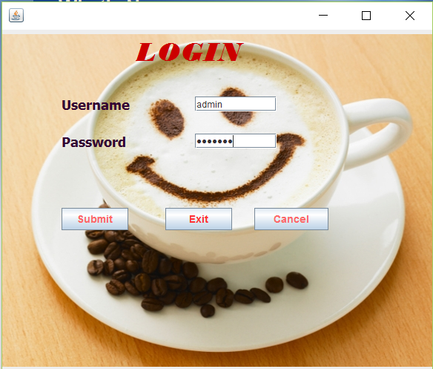

**CODING-**

**private void jButton1ActionPerformed(java.awt.event.ActionEventevt) {**

**String s,p;**

**s=jTextField1.getText();**

**p=jPasswordField1.getText();**

**if(s.equals("admin") &&p.equals("saksham"))**

**{**

**NewJFrame2 f=new NewJFrame2();**

**f.show();**

**this.dispose();**

**}**

**else**

**{JOptionPane.showMessageDialog(this,"Invalid password/username"); jTextField1.setText(" ");**

**jPasswordField1.setText(" ");}**

**private void jButton2ActionPerformed(java.awt.event.ActionEventevt) {**

**System.exit(0);**

**}**

**private void jButton3ActionPerformed(java.awt.event.ActionEventevt) {**

**jTextField1.setText(" ");**

**jPasswordField1.setText("");**

**}**

**NEWJFRAME2**

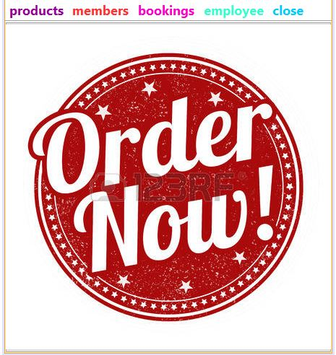

**CODING-**

**private void jMenuItem2ActionPerformed(java.awt.event.ActionEventevt) {**

**NewJFrame4 f=new NewJFrame4();**

**f.show();**

**this.dispose();**

**}**

**private void jMenuItem3ActionPerformed(java.awt.event.ActionEventevt) {**

**NewJFrame5 f=new NewJFrame5();**

**f.show();**

**this.dispose();**

**}**

**private void jMenuItem7ActionPerformed(java.awt.event.ActionEventevt) {**

**NewJFrame6 f=new NewJFrame6();**

**f.show();**

**this.dispose();**

**}**

**private void jMenuItem4ActionPerformed(java.awt.event.ActionEventevt) {**

**NewJFrame7 f=new NewJFrame7();**

**f.show();**

**this.dispose();**

**}**

**private void jMenuItem5ActionPerformed(java.awt.event.ActionEventevt) {**

**NewJFrame8 f=new NewJFrame8();**

**f.show();**

**this.dispose();**

**}**

**private void jMenuItem6ActionPerformed(java.awt.event.ActionEventevt) {**

**NewJFrame9 f=new NewJFrame9();**

**f.show();**

**this.dispose();**

**}**

**private void jMenuItem8ActionPerformed(java.awt.event.ActionEventevt) {**

**NewJFrame10 f=new NewJFrame10();**

**f.show();**

**this.dispose();**

**}**

**private void jMenuItem1ActionPerformed(java.awt.event.ActionEventevt) {**

**NewJFrame3 f=new NewJFrame3();**

**f.show();**

**this.dispose();**

**}**

**private void jMenuItem14ActionPerformed(java.awt.event.ActionEventevt) {**

**NewJFrame15 f=new NewJFrame15();**

**f.show();**

**this.dispose();**

**}**

**private void jMenuItem18ActionPerformed(java.awt.event.ActionEventevt) {**

**NewJFrame14 f=new NewJFrame14();**

**f.show();**

**this.dispose();**

**}**

**private void jMenuItem17ActionPerformed(java.awt.event.ActionEventevt) {**

**NewJFrame13 f=new NewJFrame13();**

**f.show();**

**this.dispose();**

**}**

**private void jMenuItem13ActionPerformed(java.awt.event.ActionEventevt) {**

**NewJFrame12 f=new NewJFrame12();**

**f.show();**

**this.dispose();**

**}**

**private void jMenuItem15ActionPerformed(java.awt.event.ActionEventevt) {**

**NewJFrame1 f=new NewJFrame1();**

**f.show();**

**this.dispose();**

**}**

**private void jMenuItem16ActionPerformed(java.awt.event.ActionEventevt) {**

**System.exit(0);**

**}**

**private void jButton1ActionPerformed(java.awt.event.ActionEventevt) {**

**NewJFrame11 f=new NewJFrame11();**

**f.show();**

**this.dispose();**

**} NEWJRAME3**

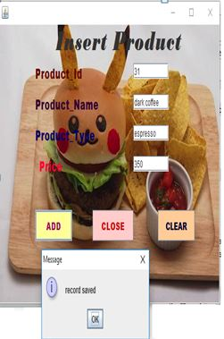

**Coding-**

**private void jButton1ActionPerformed(java.awt.event.ActionEventevt) {**

**try{**

**Class.forName("java.sql.DriverManager");**

**Connection con=DriverManager.getConnection("jdbc:mysql://localhost:3306/cafe","root","root");**

**String product_id,product_name,product_type,price,sql;**

**product_id=jTextField1.getText();**

**product_name=jTextField2.getText();**

**product_type=jTextField4.getText();**

**price=jTextField3.getText();**

**sql="insert into product values("+product_id+",'"+product_name+"','"+product_type+"',"+price+")";**

**Statement st=con.createStatement();**

**st.executeUpdate(sql);**

**JOptionPane.showMessageDialog(this,"record saved");**

**}**

**catch(Exception e){JOptionPane.showMessageDialog(this,e.getMessage());}**

**}**

**private void jButton2ActionPerformed(java.awt.event.ActionEventevt) {**

**NewJFrame2 f=new NewJFrame2();**

**f.show();**

**this.dispose();**

**}**

**private void jButton3ActionPerformed(java.awt.event.ActionEventevt) {**

**jTextField1.setText(" ");**

**jTextField2.setText(" ");**

**jTextField3.setText(" ");**

**jTextField4.setText(" ");**

**}**

**NEWJRAME4**

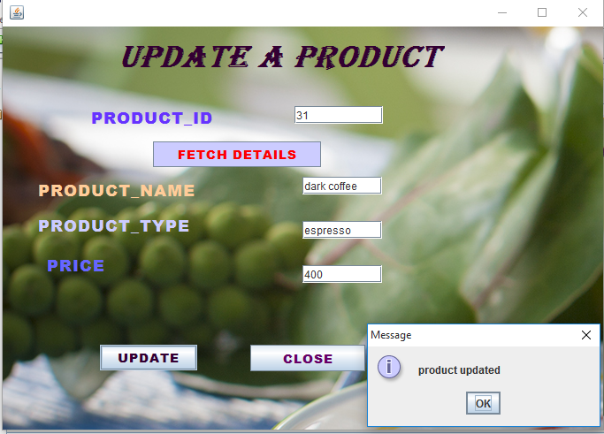

**CODING-**

**private void jButton1ActionPerformed(java.awt.event.ActionEventevt) {**

**try{**

**Class.forName("java.sql.DriverManager");**

**Connection con=DriverManager.getConnection("jdbc:mysql://localhost:3306/cafe","root","root");**

**String product_id,product_name,price,product_type,sql;**

**product_id=jTextField1.getText();**

**product_name=jTextField2.getText();**

**price=jTextField3.getText();**

**product_type=jTextField4.getText();**

**sql="update product set product_name='"+product_name+"',price="+price+" where product_id="+product_id;**

**Statement st=con.createStatement();**

**st.executeUpdate(sql);**

**JOptionPane.showMessageDialog(this,"product updated");**

**}**

**catch(Exception e){JOptionPane.showMessageDialog(this,e.getMessage());**

**}**

**private void jButton2ActionPerformed(java.awt.event.ActionEventevt) {**

**NewJFrame2 f=new NewJFrame2();**

**f.show();**

**this.dispose();**

**}**

**private void jButton3ActionPerformed(java.awt.event.ActionEventevt) {**

**try{**

**Class.forName("java.sql.DriverManager");**

**Connection con=DriverManager.getConnection("jdbc:mysql://localhost:3306/cafe","root","root");**

**String product_id,sql;**

**product_id=jTextField1.getText();**

**sql="select* from product where product_id=" +product_id;**

**Statement st=con.createStatement();**

**ResultSetrs=st.executeQuery(sql);**

**if(!rs.next())**

**JOptionPane.showMessageDialog(this,"No Such Product");**

**else{**

**jTextField2.setText(rs.getString("product_name"));**

**jTextField3.setText(rs.getString("price"));**

**jTextField4.setText(rs.getString("product_type"));**

**}**

**}**

**Catch(Exception e){JOptionPane.showMessageDialog(this,"Error"+e.getMessage());}**

**NEWJFRAME5**

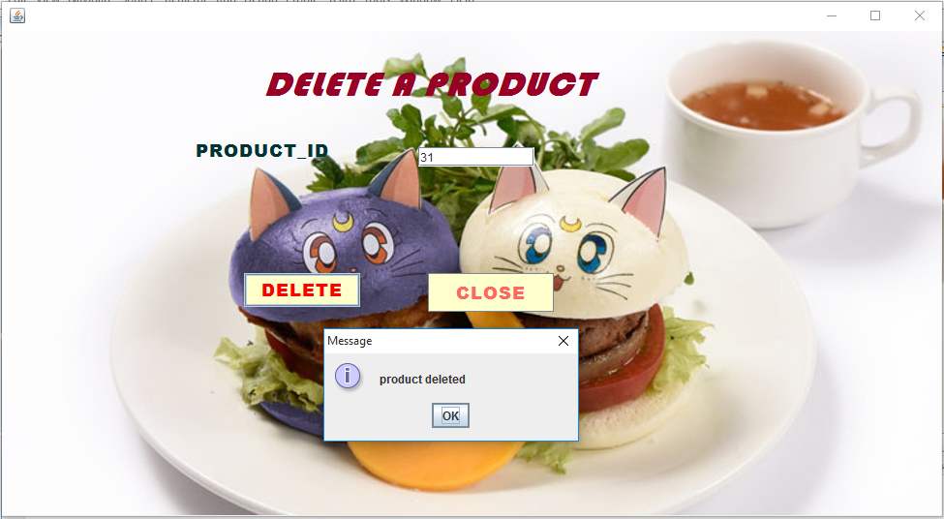

**CODING-**

**private void jButton1ActionPerformed(java.awt.event.ActionEventevt) {**

**try{**

**Class.forName("java.sql.DriverManager");**

**Connection con=DriverManager.getConnection("jdbc:mysql://localhost:3306/cafe","root","root");**

**String product_id,sql;**

**product_id=jTextField1.getText();**

**sql="delete from product where product_id="+product_id;**

**Statement st=con.createStatement();**

**st.executeUpdate(sql);**

**JOptionPane.showMessageDialog(this,"product deleted");**

**}**

**catch(Exception e){JOptionPane.showMessageDialog(this,e.getMessage());}**

**}**

**private void jButton2ActionPerformed(java.awt.event.ActionEventevt) {**

**NewJFrame2 f=new NewJFrame2();**

**f.show();**

**this.dispose();**

**}**

**NEWJRAME6**

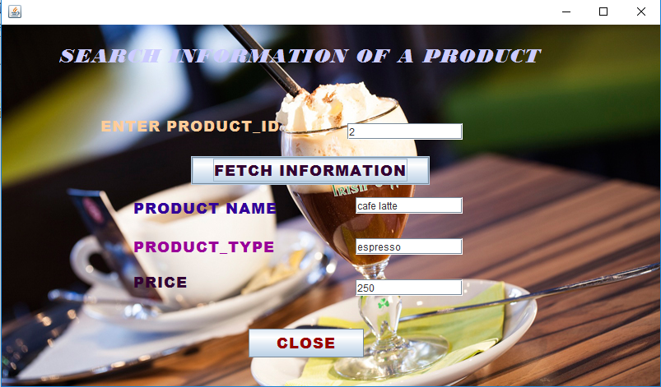

**CODING-**

**private void jButton1ActionPerformed(java.awt.event.ActionEventevt) {**

**try{**

**Class.forName("java.sql.DriverManager");**

**Connection con=DriverManager.getConnection("jdbc:mysql://localhost:3306/cafe","root","root");**

**String product_id,sql;**

**product_id=jTextField1.getText();**

**sql="select* from product where product_id=" +product_id;**

**Statement st=con.createStatement();**

**ResultSetrs=st.executeQuery(sql);**

**if(!rs.next())**

**JOptionPane.showMessageDialog(this,"No Such Product");**

**else{**

**jTextField2.setText(rs.getString("product_name"));**

**jTextField3.setText(rs.getString("price"));**

**jTextField4.setText(rs.getString("product_type"));**

**}**

**}**

**catch(Exception e){JOptionPane.showMessageDialog(this,"Error"+e.getMessage());}**

**}**

**private void jButton2ActionPerformed(java.awt.event.ActionEventevt) {**

**NewJFrame2 f=new NewJFrame2();**

**f.show();**

**this.dispose();**

**}**

**NewJFrame7**

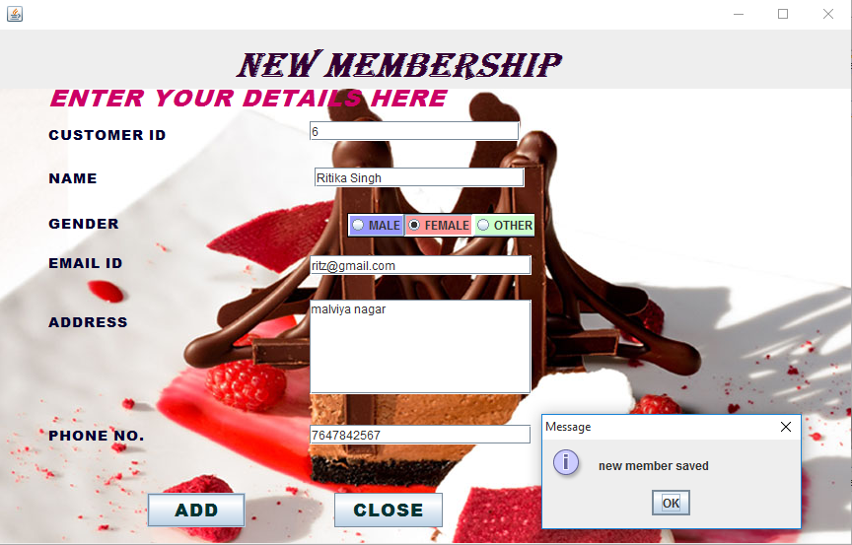

**Coding-**

**private void jButton2ActionPerformed(java.awt.event.ActionEventevt) {**

**NewJFrame2 f=new NewJFrame2();**

**f.show();**

**this.dispose();**

**}**

**private void jButton1ActionPerformed(java.awt.event.ActionEventevt) {**

**try{**

**Class.forName("java.sql.DriverManager");**

**Connection con=DriverManager.getConnection("jdbc:mysql://localhost:3306/cafe","root","root");**

**String customer_id,name,gender=" ",email_id,address,contact_no,sql;**

**customer_id=jTextField1.getText();**

**name=jTextField2.getText();**

**if(jRadioButton1.isSelected())**

**gender="male";**

**else if(jRadioButton2.isSelected())**

**gender="female";**

**else if(jRadioButton3.isSelected())**

**gender="other";**

**email_id=jTextField3.getText();**

**address=jTextArea1.getText();**

**contact_no=jTextField4.getText();**

**sql="insert into customer values("+customer_id+",'"+name+"','"+gender+"','"+email_id+"','"+address+"','"+contact_no+"')";**

**Statement st=con.createStatement();**

**st.executeUpdate(sql);**

**JOptionPane.showMessageDialog(this,"new member saved");**

**} catch(Exception e)**

**{JOptionPane.showMessageDialog(this,e.getMessage());}**

**}**

**NewJFrame8**

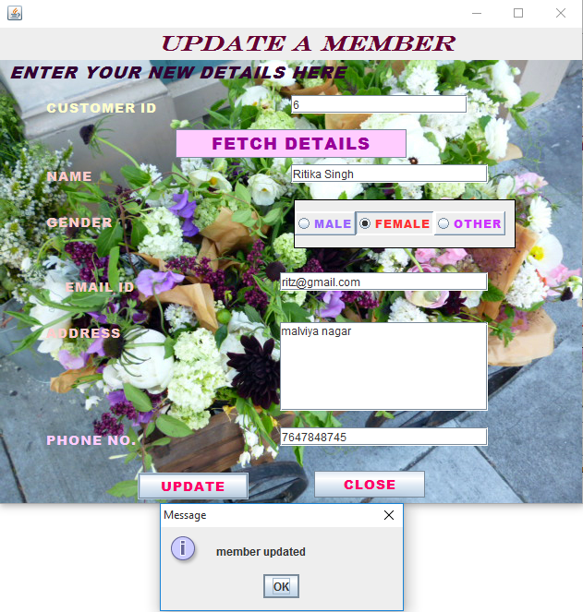

**Coding-**

**private void jButton1ActionPerformed(java.awt.event.ActionEventevt) {**

**try{**

**Class.forName("java.sql.DriverManager");**

**Connection con=DriverManager.getConnection("jdbc:mysql://localhost:3306/cafe","root","root");**

**String customer_id,name,gender=" ",email_id,address,contact_no,sql;**

**customer_id=jTextField1.getText();**

**name=jTextField2.getText();**

**if(jRadioButton1.isSelected())**

**gender="male";**

**else if(jRadioButton2.isSelected())**

**gender="female";**

**else if(jRadioButton3.isSelected())**

**gender="other";**

**email_id=jTextField3.getText();**

**address=jTextArea1.getText();**

**contact_no=jTextField4.getText();**

**sql="update customer set name='"+name+"',gender='"+gender+"',email_id='"+email_id+"',address='"+address+"',contact_no="+contact_no+" where customer_id="+customer_id;**

**Statement st=con.createStatement();**

**st.executeUpdate(sql);**

**JOptionPane.showMessageDialog(this," member updated");**

**{ catch(Exception e)**

**{JOptionPane.showMessageDialog(this,e.getMessage());}**

**}**

**private void jButton2ActionPerformed(java.awt.event.ActionEventevt) {**

**NewJFrame2 f=new NewJFrame2();**

**f.show();**

**this.dispose();**

**}**

**private void jButton3ActionPerformed(java.awt.event.ActionEventevt) {**

**try{**

**Class.forName("java.sql.DriverManager");**

**Connection con=DriverManager.getConnection("jdbc:mysql://localhost:3306/cafe","root","root");**

**String customer_id,sql;**

**customer_id=jTextField1.getText();**

**sql="select* from customer where customer_id=" +customer_id;**

**Statement st=con.createStatement();**

**ResultSetrs=st.executeQuery(sql);**

**if(!rs.next())**

**JOptionPane.showMessageDialog(this,"No Such Member");**

**else{**

**jTextField2.setText(rs.getString("name"));**

**if(rs.getString("gender").equals("male"))**

**jRadioButton1.setSelected(true);**

**else if(rs.getString("gender").equals("female"))**

**jRadioButton2.setSelected(true);**

**else if(rs.getString("gender").equals("other"))**

**jRadioButton3.setSelected(true);**

**jTextField3.setText(rs.getString("email_id"));**

**jTextArea1.setText(rs.getString("address"));**

**jTextField4.setText(rs.getString("contact_no"));**

**}**

**}**

**catch(Exception e)**

**{JOptionPane.showMessageDialog(this,"Error"+e.getMessage());}**

**NewJFrame9**

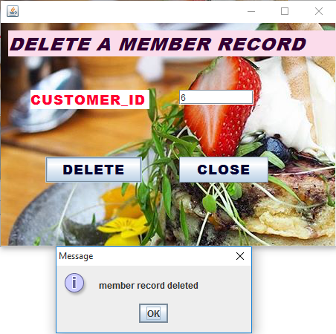

**Coding-**

**private void jButton1ActionPerformed(java.awt.event.ActionEventevt) {**

**try{**

**Class.forName("java.sql.DriverManager");**

**Connection con=DriverManager.getConnection("jdbc:mysql://localhost:3306/cafe","root","root");**

**String customer_id,sql;**

**customer_id=jTextField1.getText();**

**sql="delete from customer where customer_id="+customer_id;**

**Statement st=con.createStatement();**

**st.executeUpdate(sql);**

**JOptionPane.showMessageDialog(this,"member record deleted");**

**}**

**catch(Exception e){JOptionPane.showMessageDialog(this,e.getMessage());}**

**}**

**private void jButton2ActionPerformed(java.awt.event.ActionEventevt) {**

**NewJFrame2 f=new NewJFrame2();**

**f.show();**

**this.dispose();**

**NewJFrame10** 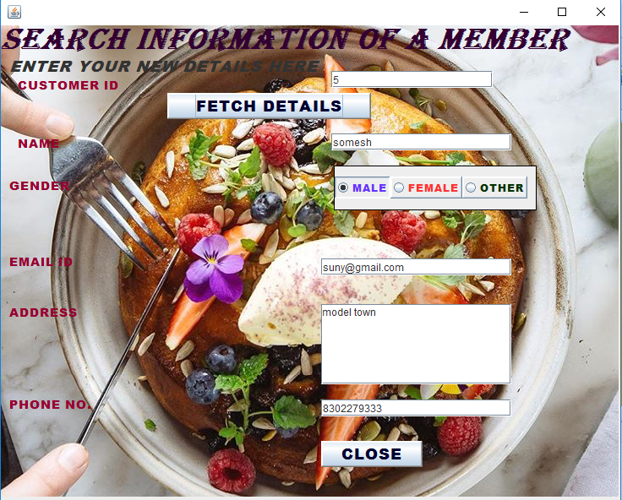

**Coding-**

**private void jButton1ActionPerformed(java.awt.event.ActionEventevt) {**

**NewJFrame2 f=new NewJFrame2();**

**f.show();**

**this.dispose();**

**}**

**private void jButton2ActionPerformed(java.awt.event.ActionEventevt) {**

**try{**

**Class.forName("java.sql.DriverManager");**

**Connection con=DriverManager.getConnection("jdbc:mysql://localhost:3306/cafe","root","root");**

**String customer_id,sql;**

**customer_id=jTextField1.getText();**

**sql="select* from customer where customer_id=" +customer_id;**

**Statement st=con.createStatement();**

**ResultSetrs=st.executeQuery(sql);**

**if(!rs.next())**

**JOptionPane.showMessageDialog(this,"No Such Product");**

**else{**

**jTextField2.setText(rs.getString("name"));**

**if(rs.getString("gender").equals("male"))**

**jRadioButton1.setSelected(true);**

**else if(rs.getString("gender").equals("female"))**

**jRadioButton2.setSelected(true);**

**else if(rs.getString("gender").equals("other"))**

**jRadioButton3.setSelected(true);**

**jTextField3.setText(rs.getString("email_id"));**

**jTextArea1.setText(rs.getString("address"));**

**jTextField4.setText(rs.getString("contact_no"));**

**}**

**} catch(Exception e){JOptionPane.showMessageDialog(this,"Error"+e.getMessage());}**

**NewJFrame11**

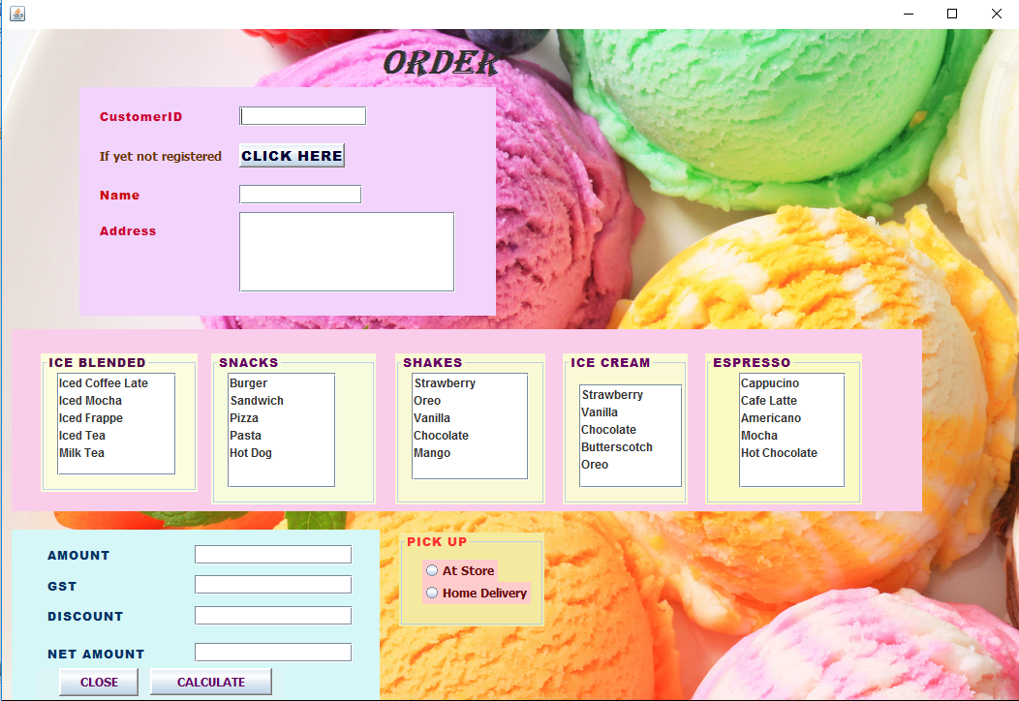

**Coding-**

**private void jTextField1ActionPerformed(java.awt.event.ActionEventevt) {**

**try{**

**Class.forName("java.sql.DriverManager");**

**Connection con=DriverManager.getConnection("jdbc:mysql://localhost:3306/cafe","root","root");**

**String customer_id,sql;**

**customer_id=jTextField1.getText();**

**sql="select* from customer where customer_id=" +customer_id;**

**Statement st=con.createStatement();**

**ResultSetrs=st.executeQuery(sql);**

**if(!rs.next())**

**JOptionPane.showMessageDialog(this,"No Such Product");**

**else{**

**jTextField2.setText(rs.getString("name"));**

**jTextArea1.setText(rs.getString("address"));**

**}**

**}**

**catch(Exception e){JOptionPane.showMessageDialog(this,"Error"+e.getMessage());}**

**}**

**private void jButton2ActionPerformed(java.awt.event.ActionEventevt) {**

**jTextField3.setEditable(false);**

**jTextField4.setEditable(false);**

**jTextField5.setEditable(false);**

**jTextField6.setEditable(false);**

**doubleamt=0,gst,netamt,dis;**

**{**

**if(jList1.isSelectedIndex(0)==true)**

**amt=amt+200;**

**if(jList1.isSelectedIndex(1)==true)**

**{ amt=amt+250;}**

**if(jList1.isSelectedIndex(2)==true)**

**amt=amt+300;**

**if(jList1.isSelectedIndex(3)==true)**

**amt=amt+350;**

**if(jList1.isSelectedIndex(4)==true)**

**amt=amt+400;**

**}**

**{**

**if(jList2.isSelectedIndex(0)==true)**

**amt=amt+200;**

**if(jList2.isSelectedIndex(1)==true)**

**{ amt=amt+250;}**

**if(jList2.isSelectedIndex(2)==true)**

**amt=amt+300;**

**if(jList2.isSelectedIndex(3)==true)**

**amt=amt+350;**

**if(jList2.isSelectedIndex(4)==true)**

**amt=amt+400;**

**}**

**{if(jList3.isSelectedIndex(0)==true)**

**amt=amt+100;**

**if(jList3.isSelectedIndex(1)==true)**

**amt=amt+150;**

**if(jList3.isSelectedIndex(2)==true)**

**amt=amt+200;**

**if(jList3.isSelectedIndex(3)==true)**

**amt=amt+100;**

**if(jList3.isSelectedIndex(4)==true)**

**amt=amt+150;**

**}**

**{**

**if(jList4.isSelectedIndex(0)==true)**

**amt=amt+100;**

**if(jList4.isSelectedIndex(1)==true)**

**{ amt=amt+100;}**

**if(jList4.isSelectedIndex(2)==true)**

**amt=amt+100;**

**if(jList4.isSelectedIndex(3)==true)**

**amt=amt+100;**

**if(jList4.isSelectedIndex(4)==true)**

**amt=amt+100;**

**}**

**{**

**if(jList5.isSelectedIndex(0)==true)**

**amt=amt+150;**

**if(jList5.isSelectedIndex(1)==true)**

**{ amt=amt+150;}**

**if(jList5.isSelectedIndex(2)==true)**

**amt=amt+150;**

**if(jList5.isSelectedIndex(3)==true)**

**amt=amt+150;**

**if(jList5.isSelectedIndex(4)==true)**

**amt=amt+150;**

**}**

**if(amt>1000)**

**dis=0.1*amt;**

**else dis=0;**

**gst=0.05*amt;**

**netamt=amt+gst-dis;**

**if(jRadioButton2.isSelected())**

**netamt=netamt+100;**

**else if(jRadioButton1.isSelected())**

**netamt=netamt+0;**

**jTextField3.setText(" "+amt);**

**jTextField4.setText(" "+gst);**

**jTextField5.setText(" "+dis);**

**jTextField6.setText(" "+netamt);**

**}**

**private void jButton1ActionPerformed(java.awt.event.ActionEventevt) {**

**NewJFrame7 f=new NewJFrame7();**

**f.show();**

**this.dispose();**

**}**

**private void jButton3ActionPerformed(java.awt.event.ActionEventevt) {**

**NewJFrame2 f=new NewJFrame2();**

**f.show();**

**this.dispose();**

**}**

**NewJFrame12**

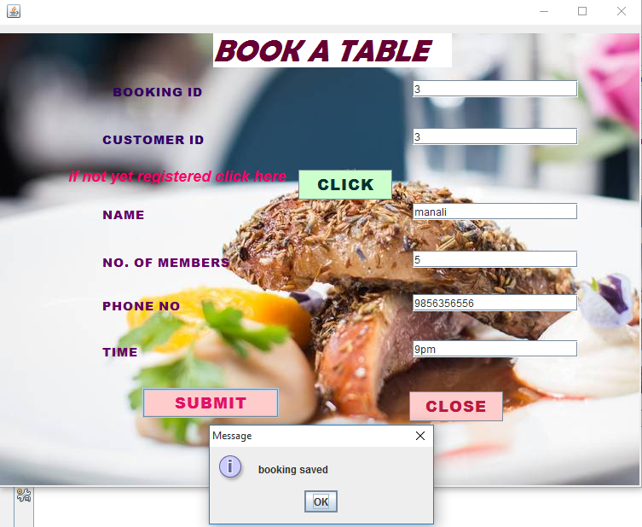

**Coding-**

**private void jButton1ActionPerformed(java.awt.event.ActionEventevt) {**

**NewJFrame3 f=new NewJFrame3();**

**f.show();**

**this.dispose();**

**}**

**private void jButton2ActionPerformed(java.awt.event.ActionEventevt) {**

**try{**

**Class.forName("java.sql.DriverManager");**

**Connection con=DriverManager.getConnection("jdbc:mysql://localhost:3306/cafe","root","root");**

**String booking_id,customer_id,name,no,phone_no,time,sql;**

**booking_id=jTextField1.getText();**

**customer_id=jTextField2.getText();**

**name=jTextField3.getText();**

**no=jTextField4.getText();**

**phone_no=jTextField5.getText();**

**time=jTextField6.getText();**

**sql="insert into booking values("+booking_id+","+customer_id+",'"+name+"',"+no+","+phone_no+",'"+time+"')";**

**Statement st=con.createStatement();**

**st.executeUpdate(sql);**

**JOptionPane.showMessageDialog(this,"booking saved");**

**}**

**catch(Exception e){JOptionPane.showMessageDialog(this,e.getMessage());}**

**}**

**private void jButton3ActionPerformed(java.awt.event.ActionEventevt) {**

**NewJFrame2 f=new NewJFrame2();**

**f.show();**

**this.dispose();**

**}**

**NewJFrame13**

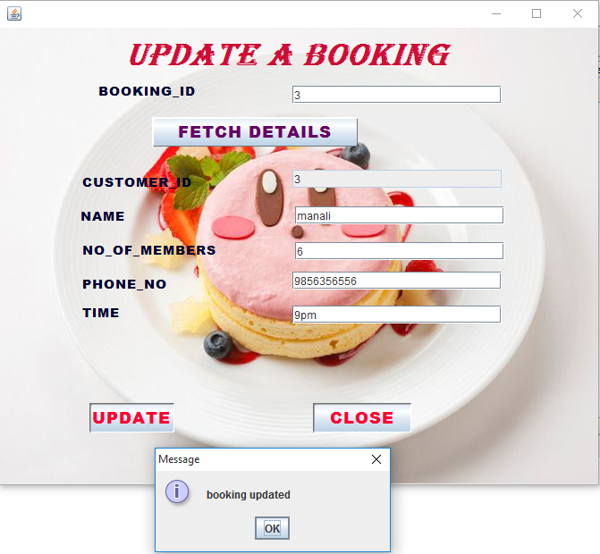

**Coding-**

**private void jButton3ActionPerformed(java.awt.event.ActionEventevt) {**

**jTextField2.setEditable(false);**

**try{**

**Class.forName("java.sql.DriverManager");**

**Connection con=DriverManager.getConnection("jdbc:mysql://localhost:3306/cafe","root","root");**

**String booking_id,sql;**

**booking_id=jTextField1.getText();**

**sql="select* from booking where booking_id=" +booking_id;**

**Statement st=con.createStatement();**

**ResultSetrs=st.executeQuery(sql);**

**if(!rs.next())**

**JOptionPane.showMessageDialog(this,"No Such Booking");**

**else{**

**jTextField2.setText(rs.getString("customer_id"));**

**jTextField3.setText(rs.getString("name"));**

**jTextField4.setText(rs.getString("no"));**

**jTextField5.setText(rs.getString("phone_no"));**

**jTextField6.setText(rs.getString("Time"));**

**}**

**} catch(Exception e)**

**{JOptionPane.showMessageDialog(this,"Error"+e.getMessage());}**

**}**

**private void jButton2ActionPerformed(java.awt.event.ActionEventevt) {**

**NewJFrame2 f=new NewJFrame2();**

**f.show();**

**this.dispose();**

**}**

**private void jButton1ActionPerformed(java.awt.event.ActionEventevt) {**

**try{**

**Class.forName("java.sql.DriverManager");**

**Connection con=DriverManager.getConnection("jdbc:mysql://localhost:3306/cafe","root","root");**

**String booking_id,customer_id,name,no,phone_no,time,sql;**

**booking_id=jTextField1.getText();**

**customer_id=jTextField2.getText();**

**name=jTextField3.getText();**

**no=jTextField4.getText();**

**phone_no=jTextField5.getText();**

**time=jTextField6.getText();**

**sql="update booking set name='"+name+"',no="+no+",phone_no="+phone_no+",time='"+time+"' where booking_id="+booking_id;**

**Statement st=con.createStatement();**

**st.executeUpdate(sql);**

**JOptionPane.showMessageDialog(this,"booking updated");**

**}**

**catch(Exception e)**

**{JOptionPane.showMessageDialog(this,e.getMessage());}**

**}**

**NewJFrame14**

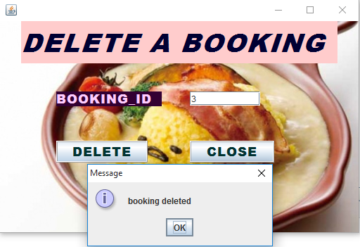

**Coding-**

**private void jButton1ActionPerformed(java.awt.event.ActionEventevt) {**

**try{**

**Class.forName("java.sql.DriverManager");**

**Connection con=DriverManager.getConnection("jdbc:mysql://localhost:3306/cafe","root","root");**

**String booking_id,sql;**

**booking_id=jTextField1.getText();**

**sql="delete from booking where booking_id="+booking_id;**

**Statement st=con.createStatement();**

**st.executeUpdate(sql);**

**JOptionPane.showMessageDialog(this,"booking deleted");**

**}**

**catch(Exception e){JOptionPane.showMessageDialog(this,e.getMessage());}**

**}**

**private void jButton2ActionPerformed(java.awt.event.ActionEventevt) {**

**NewJFrame2 f=new NewJFrame2();**

**f.show();**

**this.dispose();**

**}**

**NewJFrame15**

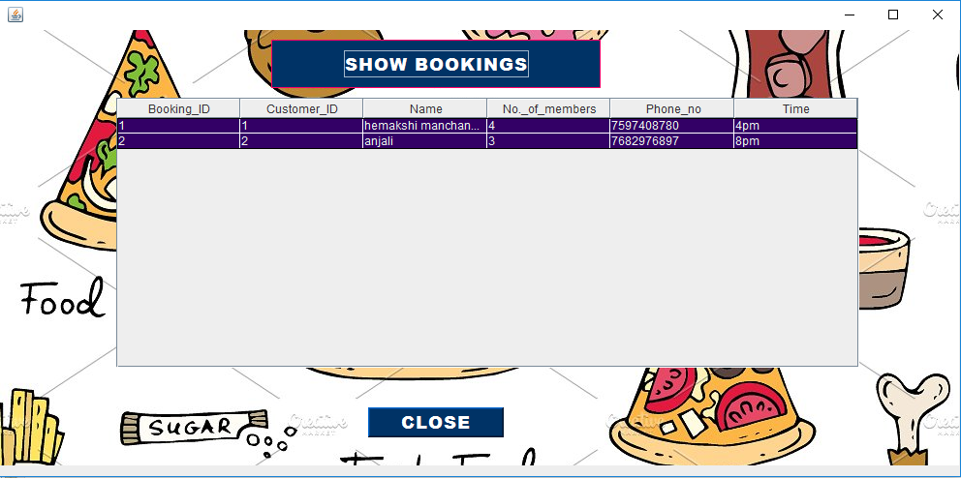

**Coding-**

**private void jButton1ActionPerformed(java.awt.event.ActionEventevt) {**

**try{**

**Class.forName("java.sql.DriverManager");**

**Connection con=DriverManager.getConnection("jdbc:mysql://localhost:3306/cafe","root","root");**

**String booking_id,customer_id,name,no,phone_no,time,sql;**

**sql="select* from booking";**

**Statement st=con.createStatement();**

**ResultSetrs=st.executeQuery(sql);**

**DefaultTableModel model=(DefaultTableModel)jTable1.getModel();**

**int rows=model.getRowCount();**

**if(rows>0){**

**for(int i=0;i<rows;i++)**

**{model.removeRow(0);**

**}**

**}**

**while(rs.next()){**

**booking_id=rs.getString("booking_id");**

**customer_id=rs.getString("customer_id");**

**name=rs.getString("name");**

**no=rs.getString("no");**

**phone_no=rs.getString("phone_no");**

**time=rs.getString("time");**

**model.addRow(new Object[]{booking_id,customer_id,name,no,phone_no,time});**

**}**

**}**

**catch(Exception e)**

**{**

**System.out.println("Error"+e.getMessage());**

**}**

**private void jButton2ActionPerformed(java.awt.event.ActionEventevt) {**

**NewJFrame2 f=new NewJFrame2();**

**f.show();**

**this.dispose();**

**}**

**NewJFrame16**

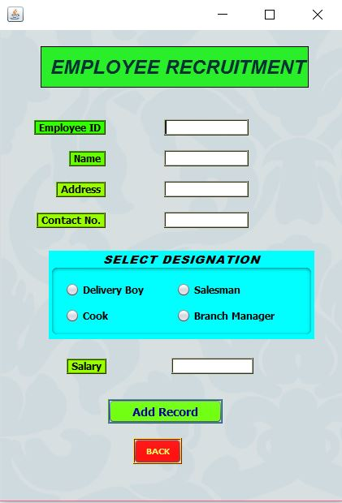

**Coding-**

**private void jButton2ActionPerformed(java.awt.event.ActionEvent evt) {**

**// TODO add your handling code here:**

**try**

**{**

**Class.forName("java.sql.DriverManager");**

**Connection con=DriverManager.getConnection("jdbc:mysql://localhost:3306/cafe","root","root");**

**String eid,name,add,cno,sal,des = null,s;**

**eid=tf1.getText();**

**name=tf2.getText();**

**add=tf3.getText();**

**cno=tf4.getText();**

**sal=tf5.getText();**

**if(rb1.isSelected()==true)**

**des="Delivery boy";**

**else if(rb2.isSelected()==true)**

**des="Salesman";**

**else if(rb3.isSelected()==true)**

**des="cook";**

**else if(rb4.isSelected()==true)**

**des="Branch Manager";**

**s="insert into emp values("+eid+",'"+name+"','"+add+"','"+cno+"','"+des+"',"+sal+")";**

**Statement st=con.createStatement();**

**st.execute(s);**

**JOptionPane.showMessageDialog(null,"Employee added");**

**tf1.setText(" ");**

**tf2.setText(" ");**

**tf3.setText(" ");**

**tf4.setText(" ");**

**tf5.setText(" ");**

**}**

**catch(Exception e)**

**{**

**JOptionPane.showMessageDialog(null,e.getMessage());**

**}**

**private void rb1ActionPerformed(java.awt.event.ActionEvent evt) {**

**float sal=5000;**

**if(rb1.isSelected())**

**tf5.setText(" "+sal);**

**}**

**private void rb2ActionPerformed(java.awt.event.ActionEvent evt) {**

**float sal=10000;**

**if(rb2.isSelected())**

**tf5.setText(" "+sal);**

**}**

**private void rb4ActionPerformed(java.awt.event.ActionEvent evt) {**

**float sal=25000;**

**if(rb4.isSelected())**

**tf5.setText(" "+sal);**

**}**

**private void rb3ActionPerformed(java.awt.event.ActionEvent evt) {**

**float sal=15000;**

**if(rb3.isSelected())**

**tf5.setText(" "+sal);**

**NewJFrame2 obj= new NewJFrame2 ();**

**obj.show();**

**this.dispose();**

**NewJFrame17**

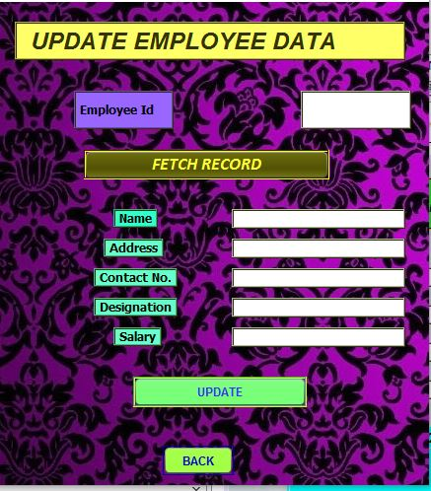

**Coding-**

**try**

**{**

**Class.forName("java.sql.DriverManager");**

**Connection con=DriverManager.getConnection("jdbc:mysql://localhost:3306/cafe","root","root");**

**String eid,name,add,cno,des,sal,s;**

**eid=tf1.getText();**

**name=tf2.getText();**

**add=tf3.getText();**

**cno=tf4.getText();**

**des=tf5.getText();**

**sal=tf6.getText();**

**s="update empl set name='"+name+"',address='"+add+"',cn_no="+cno+",designation='"+des+"',salary="+sal+" where emp_id="+eid;**

**Statement st=con.createStatement();**

**st.executeUpdate(s);**

**JOptionPane.showMessageDialog(null,"Record Updated");**

**}**

**catch(Exception e)**

**{**

**JOptionPane.showMessageDialog(null,e.getMessage());**

**}**

**private void jButton2ActionPerformed(java.awt.event.ActionEvent evt) {**

**NewJFrame2 obj= new NewJFrame2 ();**

**obj.show();**

**this.dispose();**

**NewJFrame18**

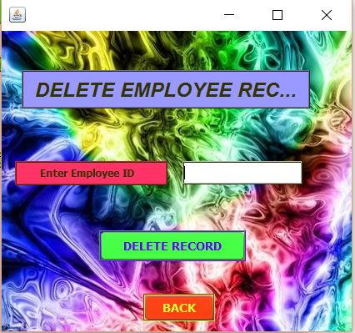

**Coding-**

**try**

**{**

**Class.forName("java.sql.DriverManager");**

**Connection con=DriverManager.getConnection("jdbc:my**

**sql://localhost:3306/cafe","root","root");**

**String eid,s;**

**eid=tf1.getText();**

**s="delete from emp where emp_id=" +eid;**

**Statement st=con.createStatement();**

**st.executeUpdate(s);**

**JOptionPane.showMessageDialog(null,"Record deleted");**

**}**

**catch(Exception e)**

**{**

**JOptionPane.showMessageDialog(null,"enter correct value");**

**}**

**private void jButton1ActionPerformed(java.awt.event.ActionEvent evt) {**

**NewJFrame2 obj= new NewJFrame2 ();**

**obj.show();**

**this.dispose();**

**NewJFrame19**

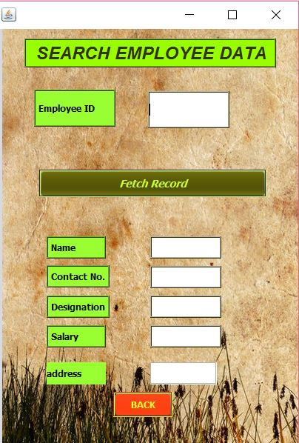

**Coding-**

**try**

**{ Class.forName("java.sql.DriverManager");**

**Connection con=DriverManager.getConnection("jdbc:mysql**

**://localhost:3306/cafe","root","root");**

**String eid,s;**

**eid=tf1.getText();**

**s="select * from emp where emp_id="+eid;**

**Statement st=con.createStatement();**

**ResultSet rs = st.executeQuery(s);**

**if(!rs.next())**

**JOptionPane.showMessageDialog(null,"no such record");**

**else**

**{**

**tf2.setText(rs.getString("name"));**

**tf3.setText(rs.getString("address"));**

**tf4.setText(rs.getString("cn_no"));**

**tf5.setText(rs.getString("designation"));**

**tf6.setText(rs.getString("salary"));}}**

**catch(Exception e)**

**{**

**JOptionPane.showMessageDialog(null,"Error"+e.getMessage());}**

**private void jButton1ActionPerformed(java.awt.event.ActionEvent evt) {**

**NewJFrame2 obj= new NewJFrame2 ();**

**obj.show();**

**this.hide();**

**NewJFrame20**

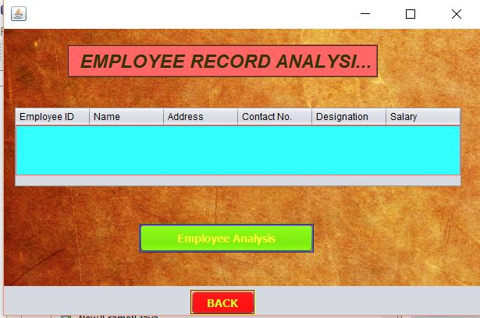

**Coding-**

**try**

**{**

**Class.forName("java.sql.DriverManager");**

**Connection con=DriverManager.getConnection("jdbc:mysql://localhost:3306/cafe","root","root");**

**String cid,cname,cadd,ccnt,cissued,crecieved,s;**

**s="select * from emp";**

**Statement st=con.createStatement();**

**ResultSet rs = st.executeQuery(s);**

**DefaultTableModel model=(DefaultTableModel)jTable1.getModel();**

**int rows=model.getRowCount();**

**if(rows>0)**

**{for(int i=0;i<rows;i++)**

**{model.removeRow(0);**

**}**

**}**

**while(rs.next())**

**{**

**cid=rs.getString("emp_id");**

**cname=rs.getString("name");**

**cadd=rs.getString("address");**

**ccnt=rs.getString("cn_no");**

**cissued=rs.getString("designation");**

**crecieved=rs.getString("salary");**

**model.addRow(new Object[]{cid,cname,cadd,ccnt,cissued,crecieved});**

**}**

**}**

**catch(Exception e)**

**{**

**JOptionPane.showMessageDialog(null,"Error"+e.getMessage());**

**NewJFrame21** 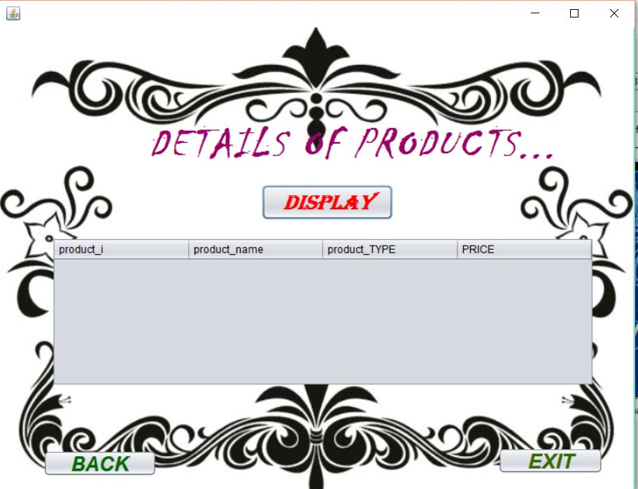

**NewJFrame2 f11=new NewJFrame2();**

**f11.setVisible(true);**

**this.setVisible(false);**

**// TODO add your handling code here:**

**}**

**private void jButton1ActionPerformed(java.awt.event.ActionEvent evt) {**

**DefaultTableModel tm=(DefaultTableModel)jTable1.getModel();**

**Connection conn;**

**Statement stmt;**

**String sql=null,product_id=null,product_name=null,product_type=null,price=null;**

**ResultSet rs=null;**

**try {**

**Class.forName("java.sql.Driver");**

**conn=DriverManager.getConnection("jdbc:mysql://localhost:3306/cafe","root","root");**

**stmt=conn.createStatement();**

**sql="select * from product;";**

**rs=stmt.executeQuery(sql);**

**rs.first();**

**do**

**{tm.addRow(new Object[]{rs.getString("product_id"),rs.getString("product_name"),rs.getString("product_type"),rs.getString("price")});**

**}while(rs.next());**

**conn.close();**

**stmt.close();**

**} catch(Exception e) {**

**System.out.println(e.getMessage());**

**; NewJFrame22**

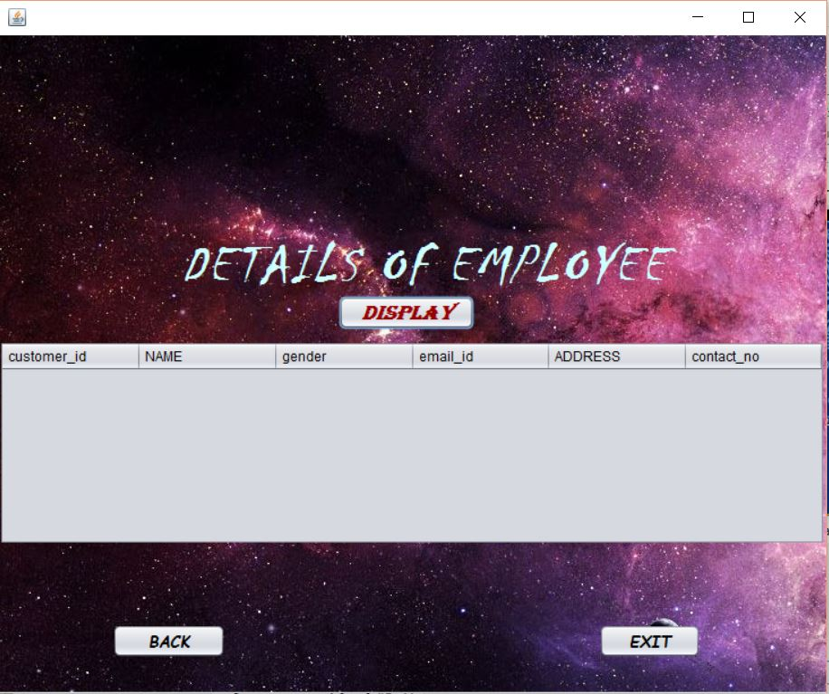

**Coding-**

**DefaultTableModel tm=(DefaultTableModel)jTable1.getModel();**

**Connection conn;**

**Statement stmt;**

**String sql=null,CUSTOMER_id=null,name=null,GENDER=null,EMAIL_ID=null,address=null,contact_no=null;**

**ResultSet rs=null;**

**try {**

**Class.forName("java.sql.Driver");**

**conn=DriverManager.getConnection("jdbc:mysql://localhost:3306/cafe","root","root");**

**stmt=conn.createStatement();**

**sql="select * from customer;";**

**rs=stmt.executeQuery(sql);**

**rs.first();**

**do**

**{tm.addRow(new Object[]{rs.getString("customer_id"),rs.getString("name"),rs.getString("gender"),rs.getString("email_id"),rs.getString("address"),rs.getString("contact_no")});**

**}while(rs.next());**

**conn.close();**

**stmt.close();**

**} catch(Exception e) {**

**System.out.println(e.getMessage());**

**}**

**// TODO add your handling code here:**

**// TODO add your handling code here:**

**}**

**private void jButton2ActionPerformed(java.awt.event.ActionEvent evt) {**

**NewJFrame2 NewJFrame22=new NewJFrame2();**

**NewJFrame22.setVisible(true);**

**this.setVisible(false**

**NewJFrame23**

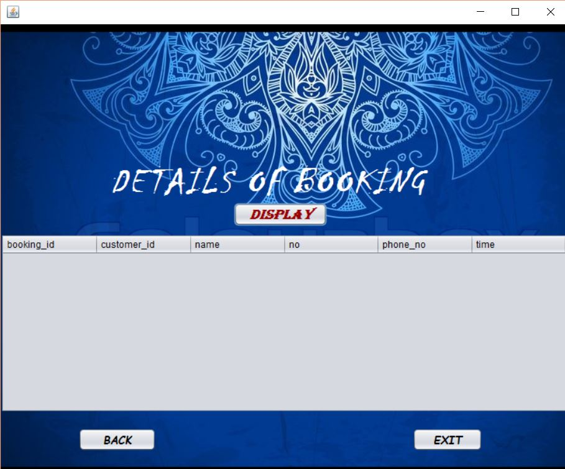

**) DefaultTableModel tm=(DefaultTableModel)jTable1.getModel();**

**Coding-**

**Connection conn;**

**Statement stmt;**

**String sql=null,booking_id=null,customer_id=null,**

**name=null,no=null,phone_no=null,time=null;**

**ResultSet rs=null;**

**try {**

**Class.forName("java.sql.Driver");**

**conn=DriverManager.getConnection("jdbc:mysql**

**://localhost:3306/cafe","root","root");**

**stmt=conn.createStatement();**

**sql="select * from booking;";**

**rs=stmt.executeQuery(sql);**

**rs.first();**

**do**

**{tm.addRow(new Object[]{rs.getString("booking_id"),rs.getString("custo**

**mer_id"),rs.getString("name"),rs.getString("no"),rs.getString("phone_no"),rs**

**.getString("time")});**

**}while(rs.next());**

**conn.close();**

**stmt.close();**

**} catch(Exception e) {**

**System.out.println(e.getMessage());**

**}**

**// TODO add your handling code here:**

**// TODO add your handling code here:**

**}**

**private void jButton2ActionPerformed(java.awt.event.ActionEvent evt) {**

**NewJFrame2 NewJFrame22=new NewJFrame2();**

**NewJFrame22.setVisible(true);**

**this.setVisible(false);**

**bibliography**

In order to work on this project titled -***Vogue – New Clothing Store,*** the following books and literature are refered by me during the various phases of development of the project.

[www.slideshare.nic](http://www.slideshare.nic)

[www.google.com](http://www.google.com)

[www.netbeans.org](http://www.netbeans.org)

[www.mysql.com](http://www.mysql.com)

Informatics Practices for class XII (CBSE)

Informatics Practices for class XII

-by Sumita Arora

Other than the above-mentioned books, the suggestions and supervision of my teacher and my class experience also helped me to develop this software project.